1. 
2. **Agenda**:
   1. We are going to install external text editor.
   2. It will make editing files simple and easy.
   3. For this we will use Visual Studio Code which is open source with a lot of features.
   4. It has many extensions which can be installed on demand.
3. There are other popular text editors like
   1. Brackets.
   2. Sublime Text.
   3. Atom
4. 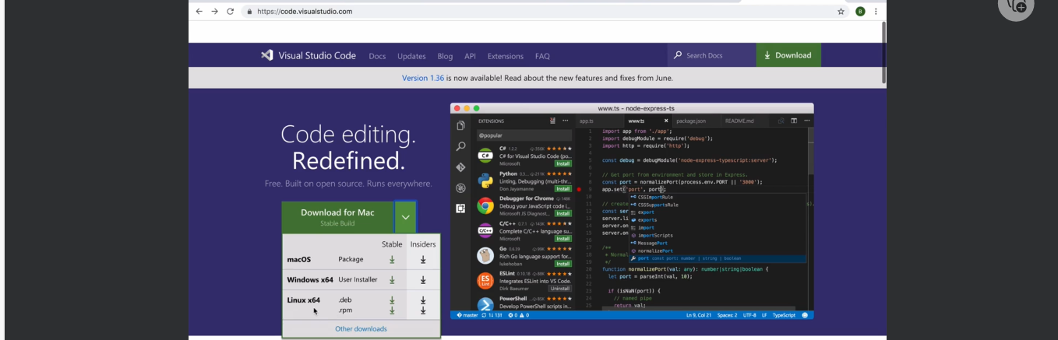
5. A screen shot of a computer

   Description automatically generated
6. A screenshot of a computer

   Description automatically generated